**A project report of**

**“A Sale Report of Zomato Restaurant”**



Session-Jan24 batch

Submitted by Susmita Maity

**Objective Questions**:

1. What is the total no. of tables present in the data?

Ans: Total no. of tables present in the data is 2.

1. What is the total no. of attributes present in the data?

Ans: Total no. of attributes present in the data is 20 without adding extra column and after adding 26 and 2nd sheet 3 more columns.

1. How many categorical columns are there in the data? [Search about categorical and continuous data, and try to answer this question]

Ans: 13 categorical columns are there in data.

1. The data consists of some inconsistent and missing values so ensure that the data used for further analysis is cleaned.

Ans: Here data is cleaned and calculated the missing values in cuisines column by using **IF, MATCH** and **INDEX**, **MODE** function.

1. Using the LookUp functions, fill up the countries in the original data using the country code.

Ans: Here using the vlookup function country name is matched with respect to

Country code.

=VLOOKUP($C2,Pivot!$A$2:B16,2,0)

1. Create a table to represent the number of restaurants opened in each country.

Ans: Creating a pivot table in excel sheet country name and restaurant name with respect to country code.

1. Also, the management wants to look at the number of restaurants opened each year, so provide them with something here.

Ans: In the pivot showing that number of restaurant respect to each year.

1. What is the total number of restaurants in India in the price range of 4?

Ans: The total number of restaurants in India in the price range of 4 is **388** by using **countif** function.

1. What is the average number of voters for the restaurants in each country according to the data?

Ans: The average number of voters for the restaurants in each country by using pivot table where country name and voters’ columns is used and number is **157.**

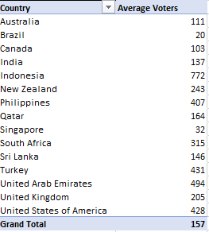

1. Calculate the average rating for all the restaurants that have price_range < 4 and provide online delivery. Use only the “IF” function, Logical Operators, and Aggregation functions to solve this problem. **[Note: Don’t use Conditional aggregation in this question.]**

Ans: The average rating is 3.27381151 by using the formula is

=AVERAGE(IF(('Raw Data'!$S$2:$S$9552<4)*('Raw Data'!$P$2:$P$9552="Yes"),'Raw Data'!$W$2:$W$9552))

1. Using Conditional formatting highlight the rows of restaurants that are located in the countries or cities that you’ve suggested to the management for opening new restaurants.

Ans: In those country restaurants have their rating is greater than 3.6 there will be suggested opening the new restaurant the restaurant is marked as dark blue.

1. Create a new customized price column that consists of the abbreviation/symbol of the currency along with the Average_cost_for_two value. [Use string operations to do this task]

Ans: To calculate the Average_cost for two value by using text to column then using concatenate function.

=_xlfn.XLOOKUP($R$5,'Raw Data'!$B$2:$B$9552,'Raw Data'!$V$2:$V$9552)

Average cost for two is 400.

1. How can you create an array formula in Excel or Google Sheets to count the number of restaurants listed that do not offer online delivery, are in the lowest price range, and have an average cost for two people less than or equal to 250 Indian Rupees?

Ans: The number of restaurants is 1685 by using this formula

=COUNTIFS('Raw Data'!$P$2:$P$9552,"No",'Raw Data'!$S$2:$S$9552,1,'Raw Data'!$U$2:$U$9552,"<=250",'Raw Data'!M2:M9552,"Indian Rupees").

**Subjective Question:**

1. Suggest a few countries where the team can open newer restaurants with lesser competition. Which visualization/technique will you use here to justify the suggestions?

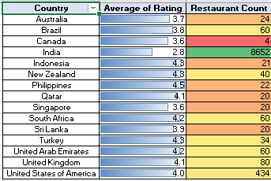

Ans: Here we say that where the Average of rating is higher than 3.6 and count of restaurant is higher than 30 there the team can open newer restaurant as my opinion. The country name is Brazil, New Zealand, South Africa, Turkey, United Arab Emirates, United Kingdom, United States of America.

2.Come up with the names of States and cities in the suggested countries suitable for opening restaurants.

Ans: We can calculate this easily by filtering out on basis of factors like as follows: 1. Selecting restaurants that doesn’t have online Table booking or Online delivery, thus we can initiate those services and try opening some,

2. Then we need to filter out the suggested countries based on the previous criteria to get lesser count.

3.Then if we select the average rating value as 3.6 or above as per the basic criteria, we get these :

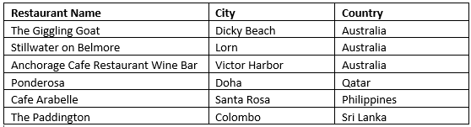

3.According to the countries you suggested, what is the current quality regarding ratings for restaurants that are open there?

Ans:

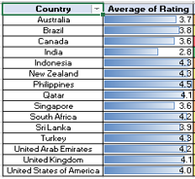

Restaurants average rating is where greater than 3.6 there we suggested that open new restaurants. We should tell that rating is too good for restaurant and environment quality should be calm and quit then restaurant should be increase.

4.Also, what is the current expenditure on food in the suggested countries, so we can keep our financial expenditure in control?

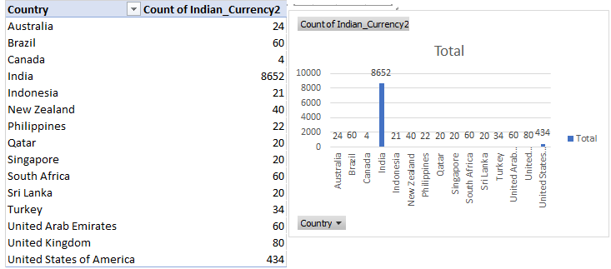

5.Come up with the names of restaurants from the recommended states that are our biggest competitors and also those that are rated in the lower brackets, i.e. 1-2 or 2-3.

Ans:

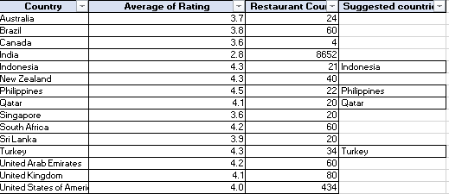

**6.**Which cuisines should we focus on in the newer restaurants to get better feedback? Does the choice of cuisines affect the restaurant ratings?

**Ans**: Cuisines with the highest votes are the ones we should focus on and yes, choice of cuisines definitely affects restaurant ratings.

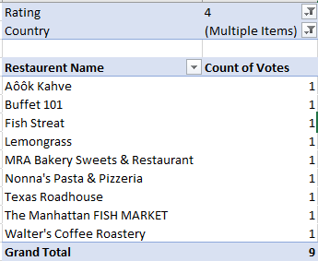

**7.**According to our current data, should we go for online delivery and table booking? Does that affect the customer’s ratings?

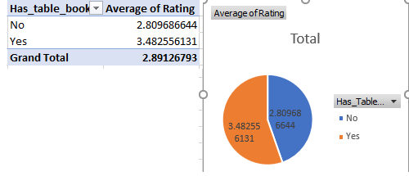

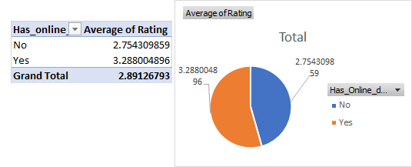

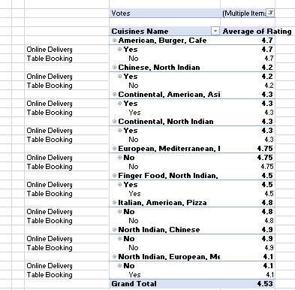

* High ratings are often given when table booking or online delivery service is available, showing that customers like having these options.
* Customers really value the convenience and time saved by online table booking and delivery services.
* If we see the top 10 cuisines according to the number of votes then we can find 6 of those are having online delivery or table booking system. And all of those are highly rated (4+)
* So introducing the online delivery and table booking become good for customers.

8.Should the team keep the rate of cuisines higher? Will that affect the feedback? According to our data are the rates of cuisines and ratings, correlated?

Here, for 4 price range, rating is 3.8 which is highest, and votes are better too.

|  |  |  |  |
| --- | --- | --- | --- |
| **Price_range** | **Average_Cost_for_two** | **Average of Votes** | **Average of Rating** |
| 1 | 275 | 45 | 2.4 |
| 2 | 597 | 148 | 3.1 |
| 3 | 5177 | 444 | 3.7 |
| 4 | 1849 | 369 | 3.8 |
| **Grand Total** | **1199** | **157** | **3** |

9.What is the distribution of the number of restaurants of different price ranges in all the countries?

**Ans**: By this comparison in a pivot table and chart, we can see the distribution between number of restaurants vs price ranges in all countries.

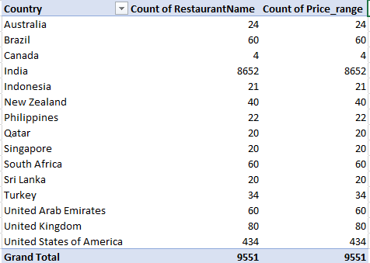

10.Explain your approach in brief for suggesting countries/cities in order to open new restaurants, if the objective and subjective questions would have been given to assist you. **[you have to give bullet pointers in order to answer this question]**

Ans:

* We can analyse that where rating is greater than 3.6 there I suggested that open new restaurant.
* Also analyse that average_cost_for_two that is affordable factor of different different area.
* We have to seen that which countries city compettion is low but population is high and restaurant number is low for people here we can launch new restaurant.
* Economic development is too much important for launching new restaurant.